32  31  31  30  31  32  31  31  32  31  30  31  31  31 | EMUFPHZLRFAXYUSDJKZLDKRNSHGNFIVJ  YQTQUXQBQVYUVLLTREVJYQTMKYRDMFD  VFPJUDEEHZWETZYVGWHKKQETGFQJNCE  GGWHKK?DQMCPFQZDQMMIAGPFXHQRLG  TIMVMZJANQLVKQEDAGDVFRPJUNGEUNA  QZGZLECGYUXUEENJTBJLBQCRTBJDFHRR  YIZETKZEMVDUFKSJHKFWHKUWQLSZFTI  HHDDDUVH?DWKBFUFPWNTDFIYCUQZERE  EVLDKFEZMOQQJLTTUGSYQPFEUNLAVIDX  FLGGTEZ?FKZBSFDQVGOGIPUFXHHDRKF  FHQNTGPUAECNUVPDJMQCLQUMUNEDFQ  ELZZVRRGKFFVOEEXBDMVPNFQXEZLGRE  DNQFMPNZGLFLPMRJQYALMGNUVPDXVKP  DQUMEBEDMHDAFMJGZNUPLGEWJLLAETG | DCBAZYXWVUSTRQPONMLKJIHGFEDCBA  PYRKZXWVUQNMLIHGFEDCBASOTPYRKA  TPYRKZXWVUQNMLJIHGFEDCBASOTPYRB  OTPYRKZXWVUQNMLJIHGFEDCBASOTPYC  SOTPYRKZXWVUQNMLJIHGFEDCBASOTPD  ASOTPYRKZXWVUQNMLJIHGFEDCBASOTE  BASOTPYRKZXWVUQNMLJIHGFEDCBASOF  CBASOTPYRKZXWVUQNMLJIHGFEDCBASG  DCBASOTPYRKZXWVUQNMLJIHGFEDCBAH  EDCBASOTPYRKZXWVUQNMLJIHGFEDCBI  FEDCBASOTPYRKZXWVUQNMLJIHGFEDCJ  GFEDCBASOTPYRKZXWVUQNMLJIHGFEDK  HGFEDCBASOTPYRKZXWVUQNMLJIHGFEL  IHGFEDCBASOTPYRKZXWVUQNMLJIHGFM | 30  31  31  31  31  31  31  31  31  31  31  31  31  31
32  30  31  30  32  30  32  31  33  29  31  31  31  31 | ENDYAHROHNLSRHEOCPTEOIBIDYSHNAIA  CHTNREYULDSLLSLLNOHSNOSMRWXMNE  TPRNGATIHNRARPESLNNELEBLPIIACAE  WMTWNDITEENRAHCTENEUDRETNHAEOE  TFOLSEDTIWENHAEIOYTEYQHEENCTAYCR  EIFTBRSPAMHHEWENATAMATEGYEERLB  TEEFOASFIOTUETUAEOTOARMAEERTNRTI  BSEDDNIAAHTTMSTEWPIEROAGRIEWFEB  AECTDDHILCEIHSITEGOEAOSDDRYDLORIT  RKLMLEHAGTDHARDPNEOHMGFMFEUHE  ECDMRIPFEIMEHNLSSTTRTVDOHW?OBKR  UOXOGHULBSOLIFBBWFLRVQQPRNGKSSO  TWTQSJQSSEKZZWATJKLUDIAWINFBNYP  VTTMZFPKWGDKZXTJCDIGKUHUAUEKCAR | L JIHGFEDCBASOTPYRKZXWVUQNMLJIHGN  LJIHGFEDCBASOTPYRKZXWVUQNMLJIHO  MLJIHGFEDCBASOTPYRKZXWVUQNMLJIP  NMLJIHGFEDCBASOTPYRKZXWVUQNMLJQ  QNMLJIHGFEDCBASOTPYRKZXWVUQNMLR  UQNMLJIHGFEDCBASOTPYRKZXWVUQNMS  VUQNMLJIHGFEDCBASOTPYRKZXWVUQNT  WVUQNMLJIHGFEDCBASOTPYRKZXWVUQU  XWVUQNMLJIHGFEDCBASOTPYRKZXWVUV  ZXWVUQNMLJIHGFEDCBASOTPYRKZXWVW  KZXWVUQNMLJIHGFEDCBASOTPYRKZXWX  RKZXWVUQNMLJIHGFEDCBASOTPYRKZXY  YRKZXWVUQNMLJIHGFEDCBASOTPYRKZZ  DBAZYXWVUSTRQPONMLKJIHGFEDCBA | 32  31  31  31  31  31  31  31  31  31  31  31  31  30

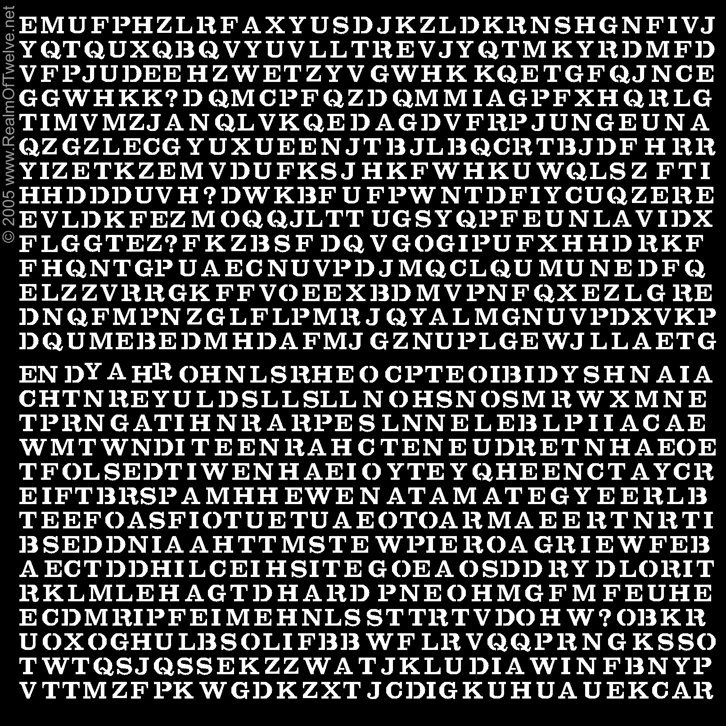

VISUAL OBSERVATION OF ENTIRE MATRIX
NUMBER | OBSERVATION | CONCLUSION
1 | ROWS HAVE DIFFENT NUMBER OF LETTERS | THE SOLUTION MUST HAVE DIFFERENT NUMBERS OF LETTERS - IN COLUMNS OR IN ROWS EG. 33 ,31 , 24 , 42
2 | RAISED LETTERS IN FIRST ROW LOWER SECTION OF CODE | POSIBLE REFFERENCE TO TIME…DAY = 24 HOURS  8 HOUR MORNING  8 HOURS EVENING  8 HOURS NIGHT
3 | VARYING GAPS BETWEEN LETTERS | POSSIBLE CLUE TO LOOK FOR IN THE SOLUTION OR UNMASKING PROCESS
4 | CODE AND OPPOSITE ALAPHABET REVERSED TO EACH OTHER | POSSIBLE CLUE THAT MATRIX MIGHT HAVE TO BE REVERESED
5 | ITS ALL IN ENGLISH ALAPHABET | ENGLISH SOLUTION – NO OTHER LANGUAGE COMPARISION
6. | OUT OF POSITION L IN FIRST ROW IN ALAPHABET | POSSIBLE INDICATES L IS SIGNIFICANT – EG….L = Q
7. | ? QUESTION MARKS ALWAYS COME AFTER A QUESTION…  4 IN TOTAL – | POSITIONS ARE NOT COUNTED WHEN USING SUBSTITION CIPHER TO FIND SOLUTION

